**Experiment 30**

**AIM :**

To design DFA transition diagram of creating substring abc in automata.

**Design and output:**

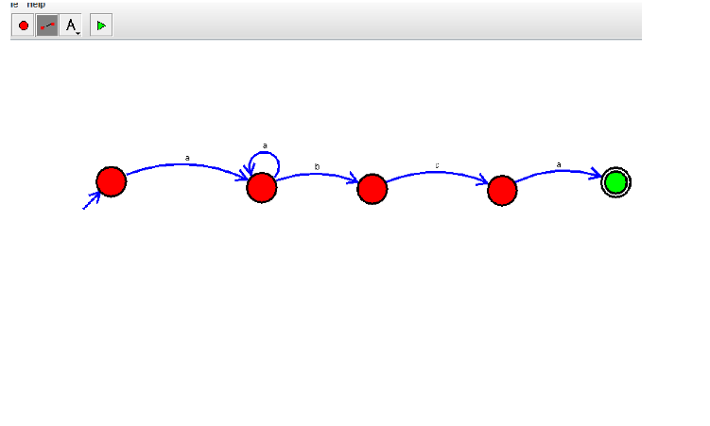

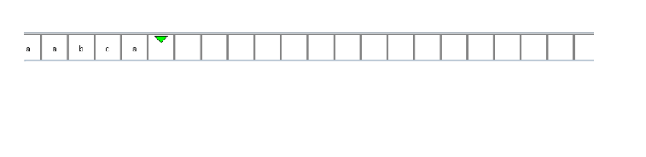

**Result:** Thus designing DFA transition diagram of creating substring abc is done and verified by giving sample inputs.